Active tectonics of the Amman-Hallabat and Shueib structures (NW of Jordan) and their implication in the Quaternary evolution of the Dead Sea Transform Fault System
Mohammad Ali Muhsin Awabdeh
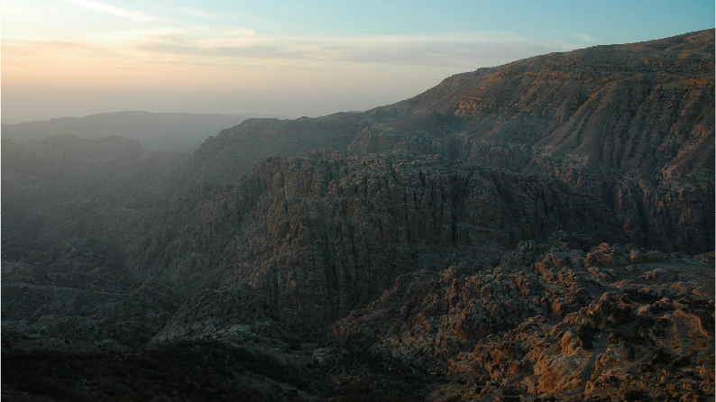
Abstract:
The Dead Sea Transform Fault (DSTF) constitutes the transform plate boundary between Africa and Arabia plates and it is one of the biggest strike-slip faults in the world (ca. 1000 km long). This fault formed by mid-Cenozoic breakup of a region that had been stable until that moment; and, therefore this breakup has not been complicated by a previous history. There are still some open questions regarding this strike-slip fault. The links between its two southern segments (Wadi Araba Fault and Jordan Valley Fault), the deformation along the Lebanon and Syrian in its northern part, or the differences in offset between its southern and northern parts remain poorly known. Moreover, active tectonic studies are scarce in some areas as in the Jordanian part of the Dead Sea Transform, which has been considered tectonically inactive in Pleistocene Times.
The southern part of this fault is divided in two main segments, the Wadi Araba Fault (WAF) and the Jordan Valley Fault (JVF) connected through the Dead Sea continental pull-apart basin. Active tectonic studies in NW Jordan have traditionally focused on these DSTF structures and have discarded other prominent structures in the region like the Amman Hallabat (AHS) and the Shueib (SHS) faults system, as they have been considered inactive from the Cretaceous. However some recent studies have suggested a possible local reactivation of the northern parts of these structures. In this Thesis I carried out a detailed geological study in the NW Jordan in order to analyze the Quaternary activity of the AHS and SHS based on landscape anlysis trhought geomorphic indexes, field observations, structural analyses and archaeological evidences of recent earthquakes.
From a methodological point of view I present in this Thesis two ArcGIS Add-Ins to automatically delineate swath and normalized river profiles. Both tools are programmed in Visual Basic .NET and use ArcObjects library-architecture to access directly to vector and raster data. The SwathProfiler Add-In allows analyzing the topography within a swath or band by representing maximum-minimum-mean elevations, first and third quartile, local relief and hypsometry. I have defined a new transverse hypsometric integral index (THi) that analyzes hypsometry along the swath and works better in this kind of representation. The NProfiler Add-In allows representing longitudinal normalized river profiles and their related morphometric indexes as normalized concavity (C_{T}), maximum concavity (C_{max}) and length of maximum concavity (L_{max}). Both tools facilitate the spatial analysis of topography and drainage networks directly in a GIS environment as ArcMap and provide graphical outputs in image (jpg) and vectorial (wmf) formats.
The landscape analysis presented in this Thesis focused in the eastern margin of the Dead Sea, with the intention of analyzing the effects that the Quaternary activity of the Dead Sea Transform Fault (DSTF) produces in the landscape and in the drainage network. This landscape analysis has two well-differentiated parts. First I analyzed the general landscape pattern through the application of spatial-based geomorphic indices as the slope, surface roughness, hypsometry and topographic swath profiles. With this analysis I aimed to describe and evaluate the general stage of landscape evolution in the study area, and examine the links between the tectonic structures and the general topographic patterns. These results of these geomorphic parameters show a good correlation with the active structures of the study area that act as boundaries for erosion processes. They also highlight a clear erosion wave advancing eastwards from the Dead Sea into the TransJordanian Plateau (TJP). Moreover, these analyses lacks clear evidences of a northern structure closing the Dead Sea apart of the NW-SE normal faults related to the AHS and SHS. Secondly, I analyzed several geomorphic indexes in order detect different pattern and highlight differences that could be due to dissimilar tectonic activity along the study area. The geomorphic indexes suggest that the study area is very young and it is in a transient state of landscape development. Normalized profiles have characteristics convex or linear-convex shapes, as well as the hypsometric curves. Area-slope plots have high Ksn values and lacks clear linear correlation, especially in their middles and lower parts (near mouths), due to the transient state of the analyzed rivers.
The field campaigns made in this Thesis have revealed that AHS and SHS structures present clear Quaternary activity and accommodate a small part of the deformation of the southern DSTF. The southwestern part of the AHS acts in the Quaternary as the northernmost continuation of the WAF, whereas the SHS works as a transfer of NW-SE normal faults with low to moderate throws that connects this structure with the JVF.
The stress analysis based on fault-slip data for two of the Amman Hallabat (AHF) and Shueib (SHF) structures suggests that most of the structures are coherent with the present-day stress pattern associated to the Dead Sea fault system. In most of the field stations there is a clear overprint of new striations over the older ones. Present-day stress in the region has horizontal to sub-horizontal maximum and minimum compressive axes (σ1 and σ3), striking NNW-SSE and ENE-SWS respectively, and a vertical intermediate stress axis (σ2). These new findings suggest a rejuvenation of the AHF and the SHF in the Quaternary in the context of the Dead Sea Transform Fault (DSTF) tectonic activity.
A seismogenic character of the AHS can be claimed from the damage found in the archaeological site of Tall el-Hamman, which has been recently interpreted as the ancient city of Sodom. The destruction of this city is attributed to big earthquake, that may be also related with this structure.
The NW-SE normal faults bounding the AHS and SHS could merge into a single fault plane that will act as the northern closure of the Dead Sea. Future geophysical research in the area should pay attention to these active structures as research in southern areas has proved fruitless.
Breve reseña curricular:
Mohammad Ali Muhsin Awabdeh es licenciado en Geología aplicada por la Universidad de Jordania (Amman, Jordania) en 2006, Máster de Geología Aplicada por la Universidad de Jordania en 2010, y cuenta con el Diploma de Estudios avanzados (DEA) por la Universidad de Granada dentro del programa de Doctorado de Ciencias de la Tierra en 2012. El comienzo de su actividad investigadora está ligado a la consecución de una beca Erasmus Mundus en 2009, y una beca de investigación posterior de la Universidad de Tafila (Jordania) en 2013. Es autor de varias publicaciones internacionales, así como numerosas aportaciones a congresos y revistas nacionales. Su campo de investigación se centra en la geología estructural y tectónica activa, y en el análisis del relieve mediante índices geomorfológicos y SIG. Su principal zona de trabajo se localiza en Jordania, en la zona central del sector sur de la transformante del Mar Muerto, una de las mayores fallas de salto en dirección del mundo. Su experiencia profesional incluye labores docentes como profesor ayudante en la Universidad de Jordania, Asistente Jefe de la sección de Geología de la Royal Scientific Society (RSS) de Jordania, y manager local y coordinador del grupo ISASTUR en Al Tafila (Jordania). Actualmente es profesor asistente en la Universidad de Tafila (Jordania), donde imparte su labor docente y investigadora desde Septiembre de 2015.
Publicaciones SCI:
- Perez-Peña, J.V., AlAwabdeh, M., Azañon, J.M., Galve, J.P. Booth-Ream G., Notti, D. (In Press). SwathProfiler and NProfiler: Two new ArcGIS Add-ins for the automatic extraction of swath and normalized river profiles. Computer & Geosciences.
- Al-Awabdeh, M., Azañón-Hernandez, J. M., Pérez-Peña, J. V., (In Press): Stress-strain analysis of the southern Dead Sea Transform Fault and adjacent structures: An episode of tectonic rejuvenation. Arabian Journal of Geosciences.
- Al-Awabdeh, M., Azañon, JM., Pérez-Peña, J. V., Booth-Rea, G., Abed, A. Atalla, M. (In Press): Quaternary tectonic activity NW Jordan: Insights for new model of transpression-transtenssion in the southern Dead Sea Transform Fault. Tectonophysics.
- J. V. Pérez-Peña, J. M. Azañón, A. Azor, G. Booth-Rea, J.P. Galve, F.J. Roldán, F. Mancilla, J. Morales, F. Giaconia, M. Al-Awabdeh. (2015): Quaternary landscape evolution driven by slab-pull mechanisms in the Granada Basin (Central Betics). Tectonophysics. Doi:10.1016/j.tecto.2015.07.035,
Publicaciones nacionales:
- Al-Awabdeh, M., Azañón, J. M., and Pérez-Peña, J. V. (2012). Recent tectonic activity in the intersection between the Amman-Hallabat structure and the Dead Sea Transform Fault ( Jordan ). Geotemas, 12, 469–472.
Aportaciones a congresos:
- M. Al-Awabdeh, J.V. Pérez-Peña, J.M. Azañón, G. Booth-Rea., (2015). Stress-Strain analysis of the southern Dead Sea Transform Fault and adjacent structures. WMESS, Prague, Czech (Poster).
- M. Al-Awabdeh, J.V. Pérez-Peña, J.M. Azañón, G. Booth-Rea., (2015). Recent transpression-transtension at the Amman-Hallabat and Shueib structures. WMESS, Prague, Czech (Oral presentation).
- Perez.Peña, J.V., AlAwabdeh, M., Galve, J.P., Azañón, J.M., Notti, D., Giaconia, F., Booth-Rea, G. (2015). R-Profiler: un complemento para ArcGIS que permite la extracción de perfiles normalizados y parámetros asociados. XIV Reunión Nacional de Cuaternario, Granada, Spain. Conference paper.
- Al-Awabdeh, Mohammad, Pérez-Peña, J. Vicente, Azañón, J. Miguel and Booth-Rea, Guillermo (2014): Neotectonic of Dead Sea pull-apart basin. A new tectonic model for its northern closure. Geophysical Research Abstracts. Vol. 16, EGU2014-4030.(Poster)
- Pérez-Peña, J.V., Azañón, J.M., Booth-Rea, G. and Al-Awabdeh, Mohammad (2014): Spatial hypsometric analysis of an intermontane basin: A key to understand the most recent tectonic evolution (Granada basin, Spain). Geophysical Research Abstracts. Vol. 16, EGU2014-4030. (Poster).
- Al-Awabdeh, M., Azañón, J.Miguel Pérez-Peña, J.Vicente, Booth-Rea, Guillermo (2014): Archaeological evidences of the tectonic activity of Shueib Structure (NW Jordan). Geophysical Research Abstracts. Vol. 16, EGU2014-4048. (Poster).

